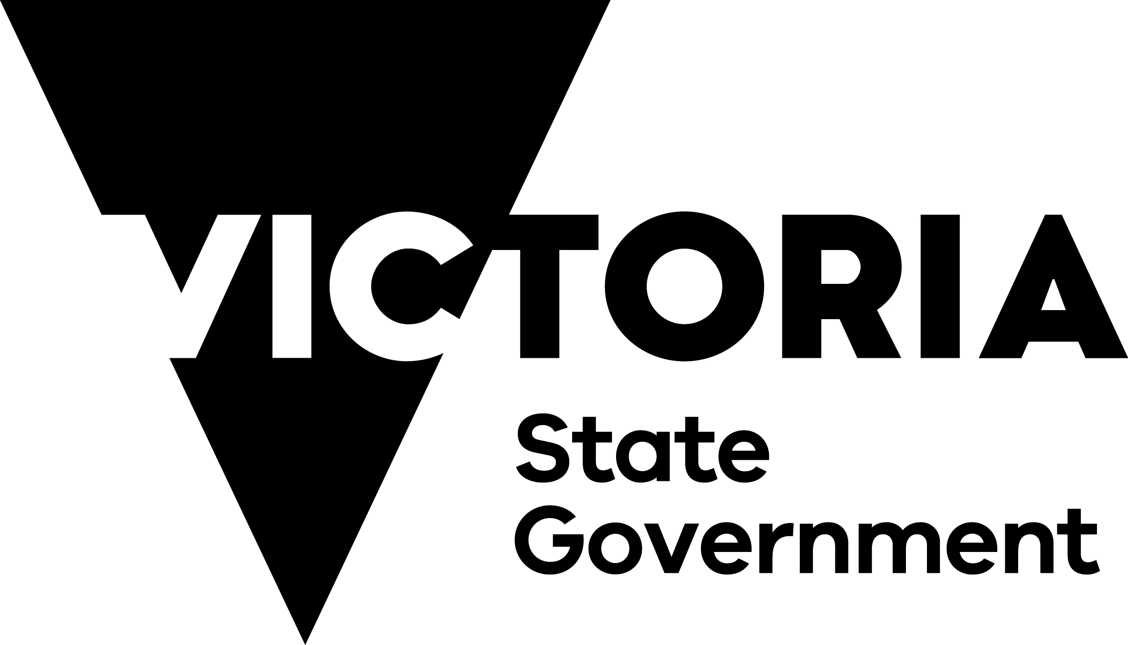

Southeast Asia Trade and Investment Snapshot

# Minister’s Foreword

The dynamic and distinct countries of Southeast Asia are some of our closest neighbours, biggest trading partners and most important relationships.

Victoria’s connection with Southeast Asia is stronger than ever.

Our relationship is built on a foundation of deep cultural and people-to-people links that have grown over many years. Victoria is proudly home to over 323,000 people from Southeast Asia who make a remarkable contribution to our state each day.

Victoria’s economic relationship with Southeast Asia has also gone from strength to strength, with two-way merchandise trade reaching a record high of A$27.4 billion in FY23. Victoria also welcomed over 45,000 international students from Southeast Asia in 2022, representing some of the region’s best and brightest.

The Victorian Government has a longstanding presence in Southeast Asia, which includes offices in Indonesia, Malaysia, Singapore and most recently Vietnam. Led by the Commissioner for Victoria to Southeast Asia, these offices work across the entire region and share valuable local knowledge with Victorian businesses looking to access new opportunities.

Our offices in-market and teams on the ground in Victoria also work closely with leading businesses in the region to support their plans to expand their operations to Victoria.

As the economies and populations   
of Southeast Asia continue to grow, the opportunities for Victorian businesses and our neighbours   
in the region will also increase.

The Australia-ASEAN Special Summit held in Melbourne in March 2024 is an important opportunity to mark the 50th anniversary of Australia-ASEAN relations while looking to the future.

The Victorian Government stands ready to support your efforts to increase trade and investment between our regions.

Because we know – it means a stronger future for all of us.

**Tim Pallas MP**   
Treasurer of Victoria  
Minister for Economic Growth

# Victoria’s engagement with Southeast Asia

Victoria’s longstanding engagement with Southeast Asia remains a priority, and two-way partnership opportunities continue to grow.

Southeast Asia continues to be a region vital to Victoria’s growth and prosperity.

With a population of over 675 million people, the distinct countries of Southeast Asia are key economic partners for Victoria. Two-way trade has grown by over 50% in the last 5 years to reach A$27.4 billion and further opportunities are expected as the region’s population increases and seeks higher-value products and services.

Southeast Asia is a significant market for Victoria’s premium food products and is an important investor in Victoria. In the last 5 years, investments from ASEAN into Victoria were worth A$2.8 billion and created over 3,500 jobs.

Our global engagement across trade, investment and international education has built strong relationships across Southeast Asia. While significant progress has been made, Victoria continues to build on what we have achieved so far to ensure our work benefits both our regions.

Our global engagement across trade, investment and international education has built strong relationships across Southeast Asia. We continue to develop partnerships to ensure our work benefits all Victorians.

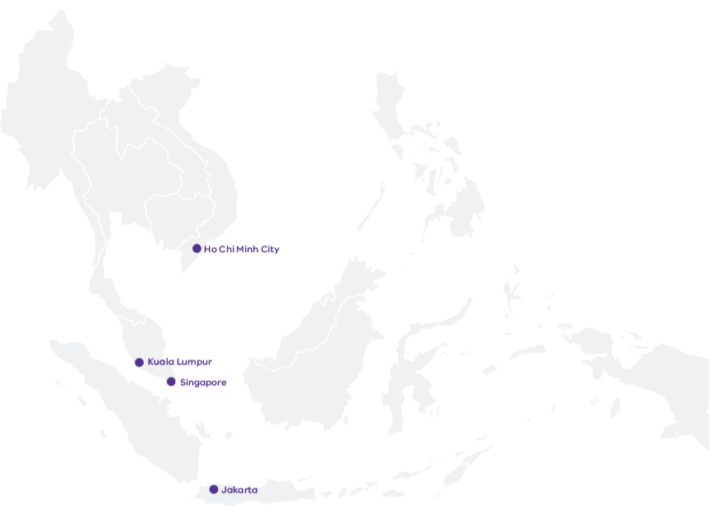

## Trade and Investment

Victorian trade and investment teams work together to support local industries to expand and create the jobs of the future for Victorians.

We have unparalleled expertise supporting Victorian businesses to succeed in Southeast Asia, and Victoria offers vast opportunities to overseas businesses looking to expand their presence in the region.

Our global network of trade and investment offices is the largest of any Australian state or territory. We work with large corporations, small and medium enterprises, business councils and bilateral chambers of commerce to access more trade and investment opportunities in Southeast Asia.

Through targeted trade missions, market access services and market intelligence, we play a crucial role in identifying and promoting emerging opportunities that align with Victorian capabilities. We provide tailored support to Victorian organisations and businesses in the region to help them achieve their goals.

We also build and strengthen relationships and networks across Southeast Asia to help businesses expand their knowledge, learn from the success of others, create new partnerships and promote products and services. This includes Southeast Asian professionals and alumni, many of whom have chosen to return to Victoria to establish businesses or returned to become key decision makers in their home countries.

## Formal frameworks for connection and cooperation

Victoria has continued to strengthen its relationships across the region through   
several formal partnerships with priority partners. These include:

Memorandum of Understanding with the People’s Committee of Ho Chi Minh City, Vietnam

Letter of Intent with West Java, Indonesia, and

Memorandum of Understanding with the Government of Yogyakarta Special Region, Indonesia.

These formal frameworks add to our longstanding people-to-people connections and increase the support available to businesses and institutions working across a range of sectors, including science and technology, creative industries, innovation and education.

## Two-way Visits by Senior Ministers and Officials

Victoria’s economic relationship with Southeast Asia is underpinned by strong relationships.

Several high-level visits by Victorian Ministers and officials have taken place in recent years, and Victoria has welcomed senior leaders and delegations from across the region.

These visits have enabled two-way progress to be made across multiple sectors and portfolios, including education, life sciences, agrifood, innovative technology and cultural exchanges.

## International Education

International education is the cornerstone of our relationship with the region. With Melbourne home to world-class institutions and recognised as Australia’s best student city, Victoria is well placed to meet the needs   
of the region as it looks to achieve its goals.

Education generates global opportunities and connections across communities, academia and the economy. International students are a pool of global talent supporting Victoria and Southeast Asia’s skills needs across high growth and innovative industries.

Through its [Commitment to Action](https://www.studymelbourne.vic.gov.au/industry/programs/improving-international-student-employment-outcomes), the Victorian Government is working to improve employment outcomes for international students and graduates and support them to gain skills and experience in their chosen field.

Looking ahead there is opportunity for industry and education and training providers to develop and promote green and sustainability qualifications for Southeast Asia to support its energy transition. Micro-credentials are one cost-effective method of upskilling at scale and in a way that supports bespoke industry and workforce training or certification.

Victoria’s TAFEs are also well placed to respond to opportunities to deliver industry-recognised micro-credentials in areas such as tourism and hospitality, ICT, cybersecurity, construction and food production.

### Victoria’s Transnational Education Partnerships Grow in Southeast Asia

Victorian universities have expanded their presence across Southeast Asia, building on longstanding ties while also innovating to explore new opportunities. Deakin University recently announced its plans to partner with Lancaster University (UK) and establish a joint international branch campus in Bandung, Indonesia. This follows Monash University becoming the first foreign university in Indonesia in 2022 when it opened its campus in Greater Jakarta. Other Victorian institutions with a longstanding presence in the region include Victoria University through its partnership with Sunway College in Kuala Lumpur, as well as Swinburne University and RMIT.

The presence of Victorian universities in the region is complemented by the Victorian Government’s Study Melbourne Hubs in Malaysia and Vietnam, which provide an in-country presence to support and engage with international students and promote Victoria as a study destination.

# Key areas for collaboration between Victoria and Southeast Asia

There are significant opportunities for collaboration between our regions   
– bringing benefits for both Southeast Asia and Victoria.

## Food and Agribusiness

Victoria is home to some of the world’s cleanest, greenest and safest food and fibre products. With agrifood systems built on the highest biosecurity and safety standards, Victorian produce has earned a global reputation for premium quality products.

Exports of Victorian food and fibre to Southeast Asia climbed from A$2.4 billion in FY18 to A$4.4 billion in FY23. As Australia’s largest exporter of food and fibre products, Victoria supplies the region with dairy, meat and premium fruits.

With Southeast Asia’s demand for meat, seafood, dairy and manufactured food expected to grow, there are opportunities for cleaner, more sustainable and ethically sourced food products. Victoria is also well placed to leverage its strengths in alternative proteins and attract traditional food manufacturers to develop new product lines that can go global.

## Digital Economy

With Melbourne recognised as one of the best cities in the world for technology companies, Victoria’s technology and innovation capabilities are driving our digital economy.

Global tech firms and Australia’s leading ASX technology companies have chosen to base themselves in Victoria, paving the way to realise the two-way opportunities that Southeast Asia presents for digital technologies including e-commerce.

The powerful combination of Victoria’s innovation capabilities and strong economy makes the state one of the best places to invest and do business. Victoria has a strong track record in transforming start-ups into high growth firms and has world-leading capabilities in FinTech, SportsTech and EdTech.

### Success in Southeast Asia for That’s Amore Cheese

Global Victoria has been supporting the global aspirations of Melbourne-based company That’s Amore Cheese for over many years. Founded in 2008 by passionate artisanal cheese maker Giorgio Linguanti, the multi award-winning company manufactures a range of Italian-style soft curd cheeses in Victoria. That’s Amore Cheese’s halal-certified and preservative-free cheeses have attracted strong interest from overseas buyers seeking premium quality, traceable and safe dairy products for their retail and food service industries. Global Victoria has supported That’s Amore Cheese to showcase their premium products at major international food shows including Food and Hotel Asia in Singapore and Food and Hotel Vietnam, which has played a key role in the business’ export success across Southeast Asia.

## Professional Services

Victoria’s growing professional services sector is a vital enabler of growth across a range of companies operating in urban design, architecture, consulting, finance, legal and accounting.

As a professional services hub, Victoria is home to a world-leading superannuation sector, headquarters for seven of the top 20 ASX listed mining and metals companies, as well as excellent design, engineering, and environmental services. Regional opportunities are growing in financial technology, mining and technical services.

## Advanced Manufacturing

Victoria has a proud history as a regional leader in advanced manufacturing and is one of the few places in the world that covers the entire manufacturing spectrum, from R&D and engineering to design, production and post-production activities like data-based services.

Victoria provides 30% of Australia’s manufacturing output and is home to a network of specialised advanced manufacturing research precincts servicing a range of industries. With a long tradition in automotive, aerospace, defence, metal, food, medtech, chemical and general manufacturing, Victoria continues to be the destination of choice for leading businesses including Moderna, CSL and Hanwha Defense Australia.

As global manufacturing evolves, Victorian companies are leading the way in using advanced technologies, expanding their R&D and creating new partnerships and international connections

## Green Energy Transition

The green energy transition presents significant opportunities for both Victoria and Southeast Asia.

Victoria’s work to tackle climate change makes us Australia’s climate leader and one of the most ambitious jurisdictions in the world. Meanwhile, Malaysia and Vietnam have the largest solar manufacturing capacity outside of China, with Malaysia, Thailand, Indonesia, the Philippines and Vietnam emerging as regional players in the battery storage value chain.

Melbourne is consistently ranked as one of the world’s most liveable cities and has the know-how across the liveability sector in environmental solutions, cleantech, water management and planning.

As one of the first jurisdictions in the world to legislate a net-zero emissions target by 2045, Victoria has the expertise and technology to assist Southeast Asia with its energy transition goals. Victoria is also strongly positioned to act as a research and development partner and host technology trials using our world-class university facilities.

The green energy transition also presents the opportunity for Victoria to collaborate with the region to secure diverse and resilient energy supply chains, particularly as they relate to solar power, electric vehicles and battery storage.

## Health and Life Sciences

Victoria is an exceptional location for biotechnology and Melbourne is one of the world’s highest-ranked life sciences hubs.

Singaporean company Oncoshot is just one of many global firms that have chosen to have a base in Melbourne. These companies are known for their excellence and innovation in the development of products, biopharma manufacturing and mRNA research.

Victoria’s pharmaceutical manufacturing continues to produce life-saving vaccines for Australia and the world. Broader strengths include genetics and genomics, neuroscience, regenerative and personalised medicine, innovative therapeutics and diagnostics and digital health. Melbourne is also one of only 3 cities in the world to have 2 universities in the global top 20 biomedical rankings, with Monash University regularly ranked in the world’s top 2 for pharmaceutical sciences.

## Creative Industries

Digital games is the fastest growing segment of the global screen entertainment industry, and Melbourne leads the way with talent, skills, services and support.

Melbourne is the largest games marketplace in the Asia-Pacific and hosts the largest games event (Melbourne International Games Week) and eSports competition in the region (Melbourne eSports Open).

Victoria is home to leading international companies and practitioners in the arts and leads the way in commercial exporting of creative industries including design, digital games, visual effects and contemporary music.

## Women in Business

Victoria recognises the importance of realising the global ambitions of women in business, and the Victorian Government is committed to meaningful inclusion and ensuring gender equality.

Our Global Victoria Women (GVw) program promotes the increased participation of women in international business. GVw works innovatively to help women connect and expand their global networks, upskill their capabilities and be decision makers in their organisations. GVw also provides a platform to showcase female leaders and share their pathways to success, promoting peer-to-peer learning.

### Bukalapak taps Melbourne for talent

Indonesia’s first publicly listed tech unicorn Bukalapak chose to establish its first international base and technology hub in Melbourne. The hub’s focus on Big Data, IoT, and AI will help Bukalapak’s mission to digitise millions of Indonesian micro-businesses. Bukalapak’s rapid growth led them to Melbourne, where access to top-tier tech talent will allow for more innovative product development and an expansion of their tech capabilities and servicing.

Invest Victoria worked closely with Bukalapak throughout its investment journey, making connections with industry and potential partners and providing advice on Victoria’s market potential and dynamic business environment. Bukalapak also entered a relationship with Victoria’s most highly ranked university (the University of Melbourne), which gave them access to skilled engineers and information technology specialists who will ultimately contribute to innovative product development and increase the skills of its Indonesian and Australian operations.

**For more information on how to connect with Victoria’s Southeast Asia Trade and Investment offices**

<https://global.vic.gov.au/explore-our-global-markets/southeast-asia>